Git access and commint code into branch :

1. Create git account
2. Create a repository
3. Install git in computer .
4. # git clone <https://github.com/pknobody007/study.git>

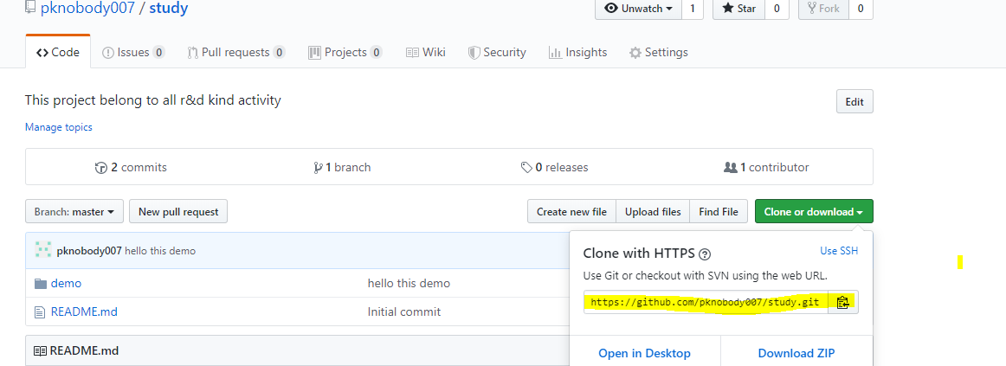

1. git push https://github.com/pknobody007/study.git

ask for git login.

Provide your git account user name and password .

1. add any folder and file into current directory

#git add <file/folder name>

# git commit –m “any relevant message ”

#git push https://github.com/pknobody007/study.git